
 | 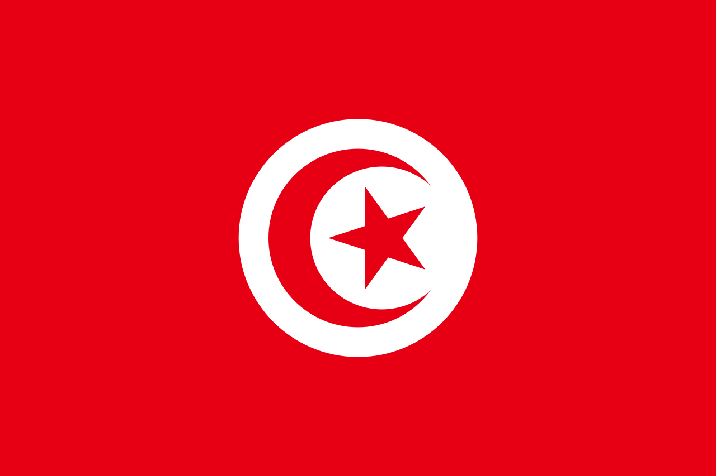 | 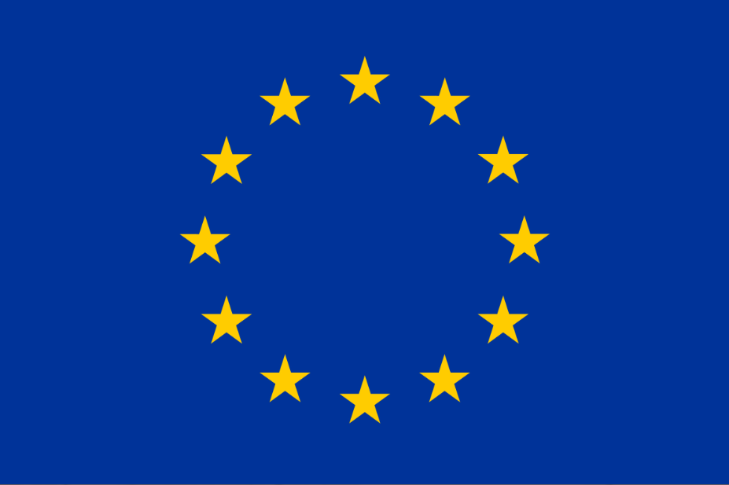 | 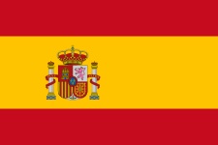 | 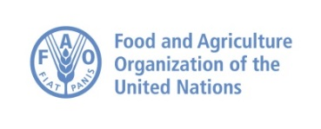

Provisional Agenda of the 23rd JPC/REMESA 2021
co-chair : Spain – Tunisia
Video-conference Wednesday 24 November 2021 (10.00 – 14.00 CET)

 | Wednesday 24 November 2021
 | Time | Theme / Speaker
 | Opening Session: Presidency Spain
 | 10.00-10.25 | Session 1: Opening ceremony  - Co-presidents: Dr Almansa Valentín de Lara (CVO Spain) and Dr Hichem Bouzghaia (CVO Tunisia)  - OIE  - FAO
 | Presidency: Presidency Tunisia
 | 10.25-10.30 | Approval of the agenda
 | 10.30-11.15 | Session 1: Update on major diseases events:  - Updates on major events occurred in the Mediterranean Region– (REMESA Secretariat -10min)  - Discussion:  - Countries have the possibility to share any relevant major updates (PPT or comments) about sanitary events (if any)
 | Presidency Spain
 | 11.15-12.50 | - FAO/OIE/ AU-IBAR PPR – updates of the 3rd Regional Road map consultation for the North African countries held from 27 to 29 November 2021 - (REMESA Secretariat -10min)  - Updates, discussion, and validation of the governance mechanism of STOR Unit in Palermo (Italy/ STOR-10 min)  - EuFMD updates (and the related activities/budget in support to REMESA) (EuFMD-10 min)  - Renewed partnership with the Southern Neighbourhood - A new agenda for the Mediterranean - (EU speaker/s tbc)  Discussion
 | 12.50-13.00 | Coffee-break
 | 13.00-13.40 | - AMR-MPTF project in Morocco (REMESA Secretariat - 10min)  - Strengthening resilience face to agro-terrorism and agro-crime affecting animal health project REMESA Secretariat - 10min)  - REMESA and link with GF-TADs (GF-TADs Secretariat- 10 min)  Discussion
 | 13.40-13.50 | Next Co-Presidency  Next JPC meeting
 | 13.50-14.00 | Wrap up and closing remarks

